Nonogram game report:

1.introduction of the game:

Nonogram consist of a table, contain black and white dot. Each row and colu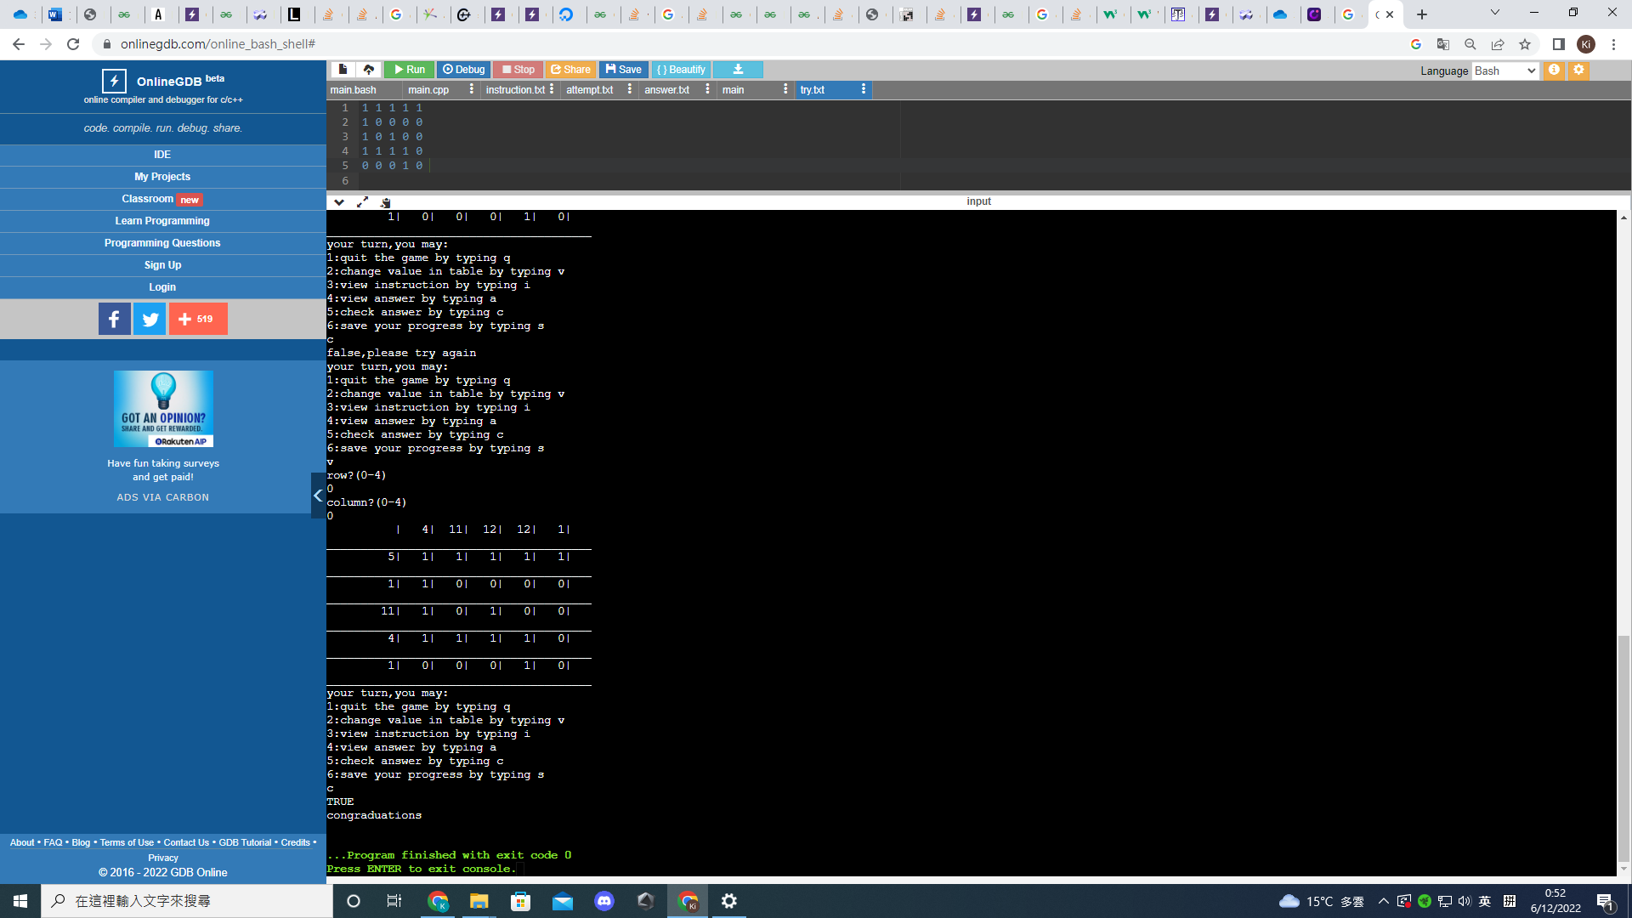mn have a set of numbers, for example “1 2” represents there are 2 parts that are black, first one only ocupies 1 spaces, and the second one ocupies two spaces.

The task is to fill the spaces such that it fulfill the requirements of rows and columns, for example. In the table ,”4” is fullfill by 4-consecutive1 “11110”, and “1 1”is fullfill by “10100”.

2. the program:

The program consist of numerous parts.

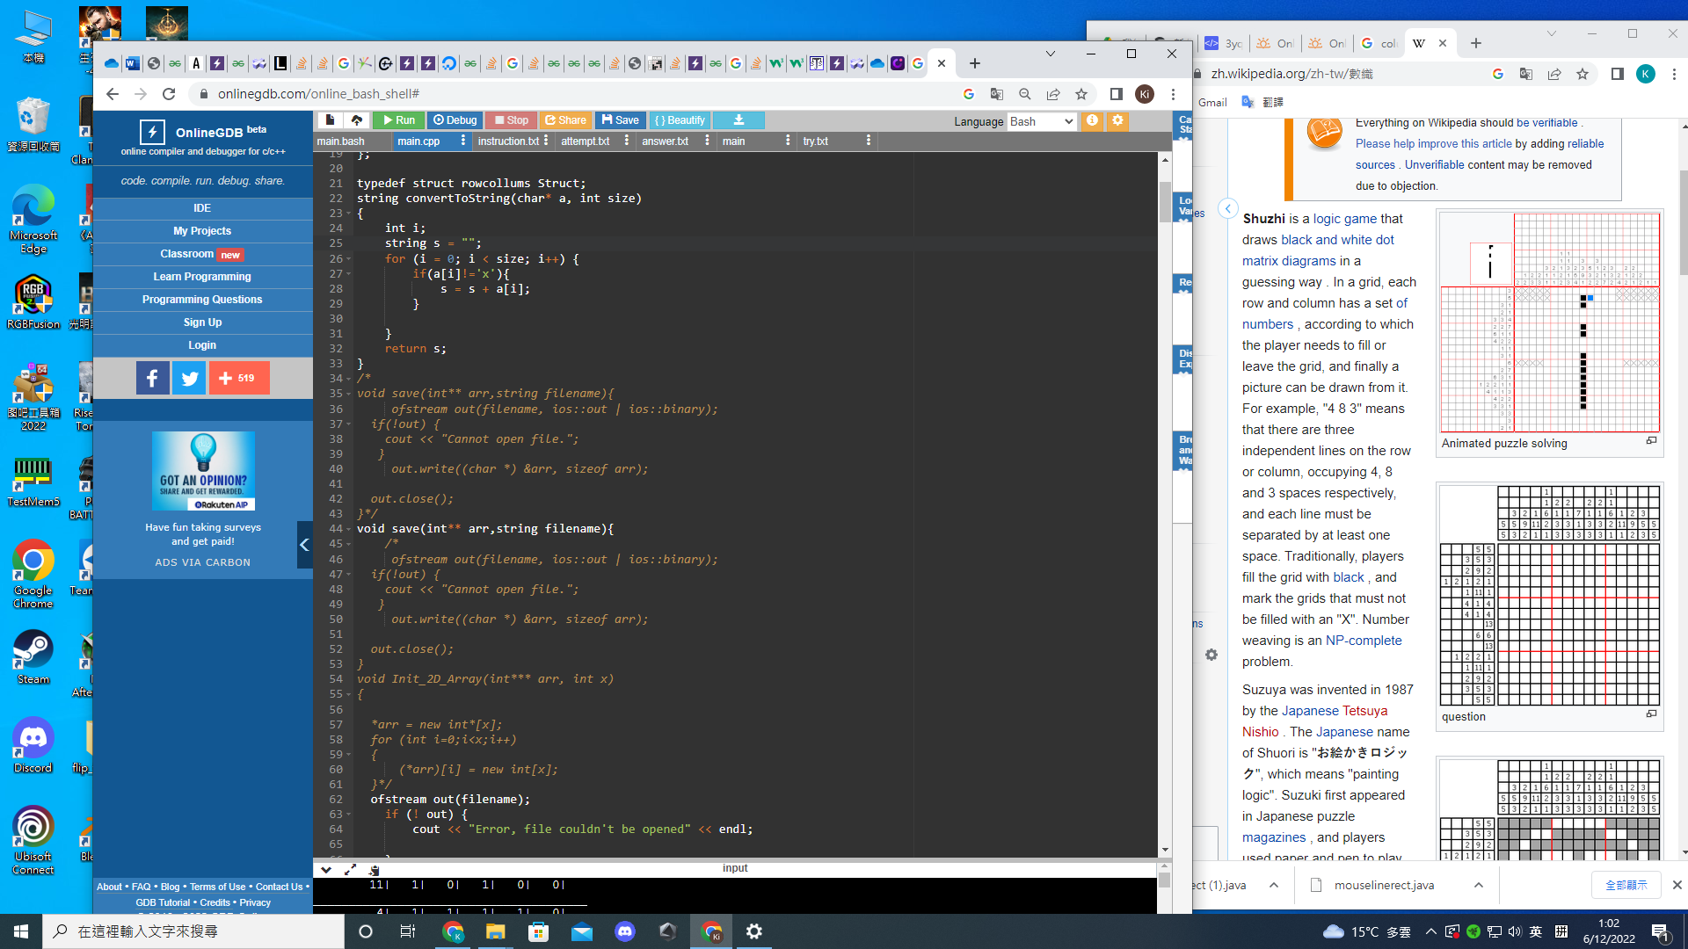

The convertToString() funtion generate the requirements of rows and coloumn from char array

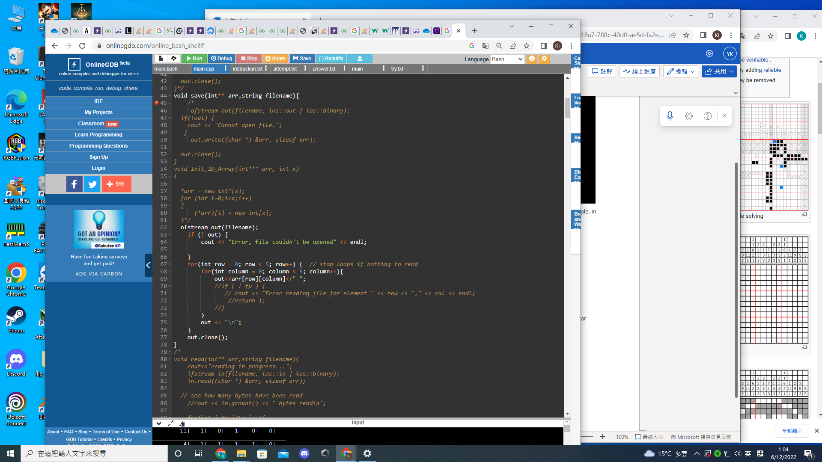

The save() fuction save the correct answer and the current attempt by player to two file,anwer.txt and try.txt

The read fuction help recover the less saved session from anwer.txt and try.txt

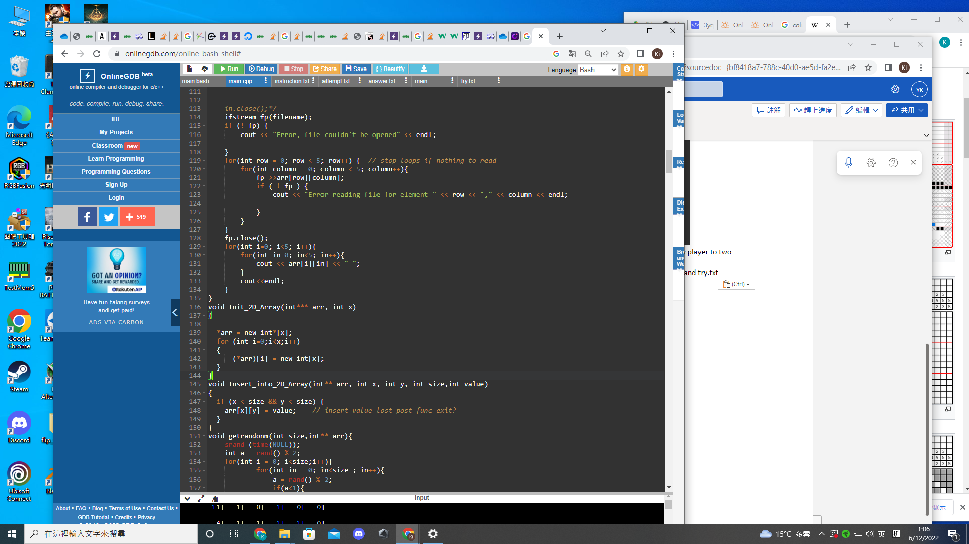

Init 2d array ()help generate dynamic array with specfic size

Insert_into2d array() help correct individual spaces

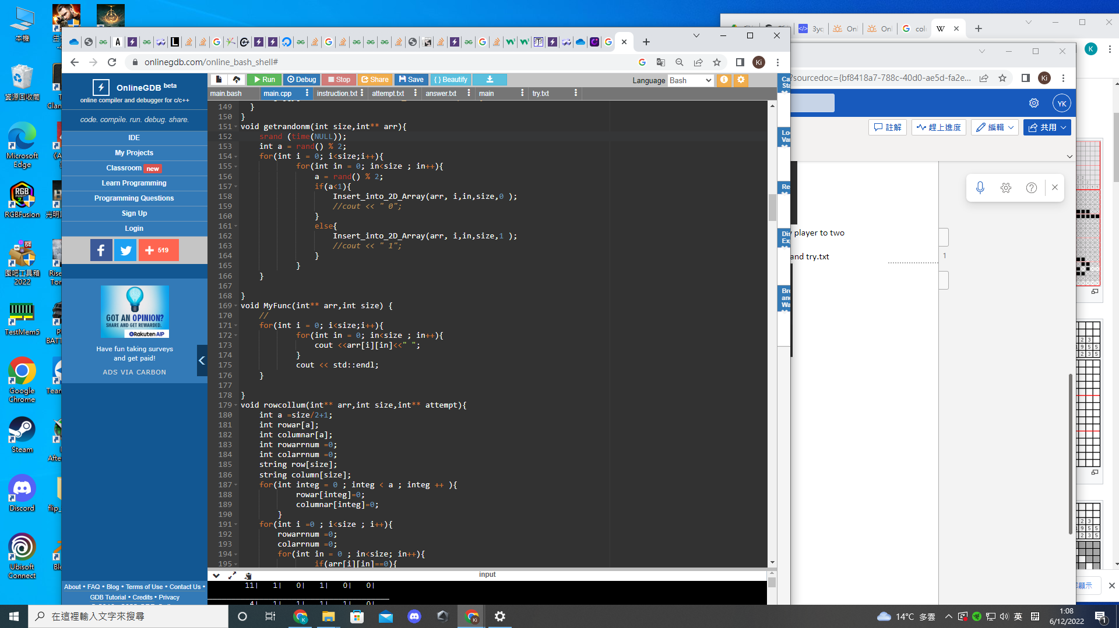

Getrandom () will generate a new game set with conntaining random individual spaces

MyFunc () help print the arr of correct answer

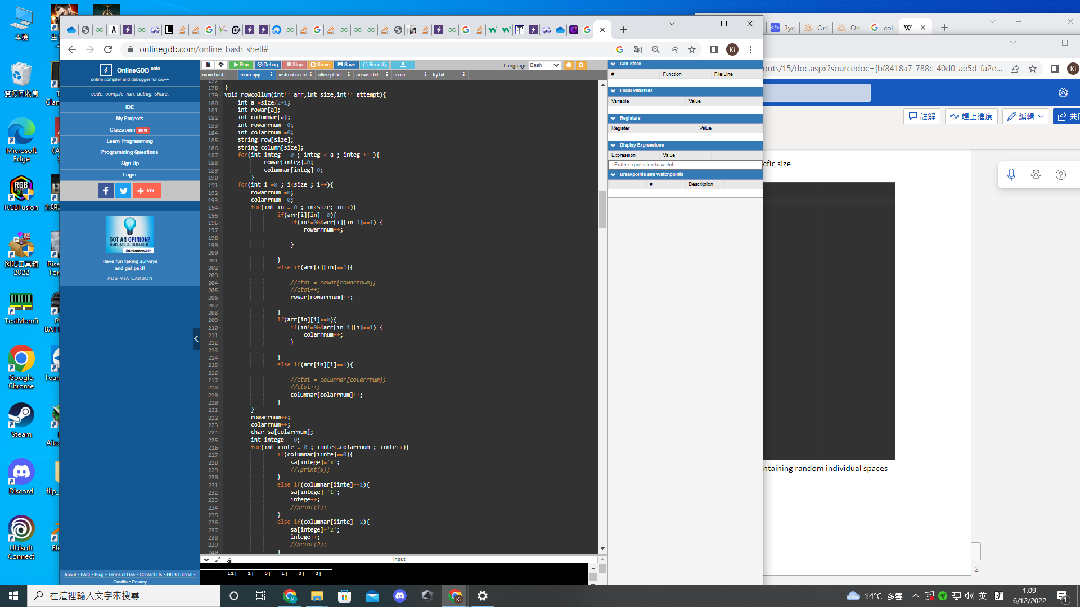

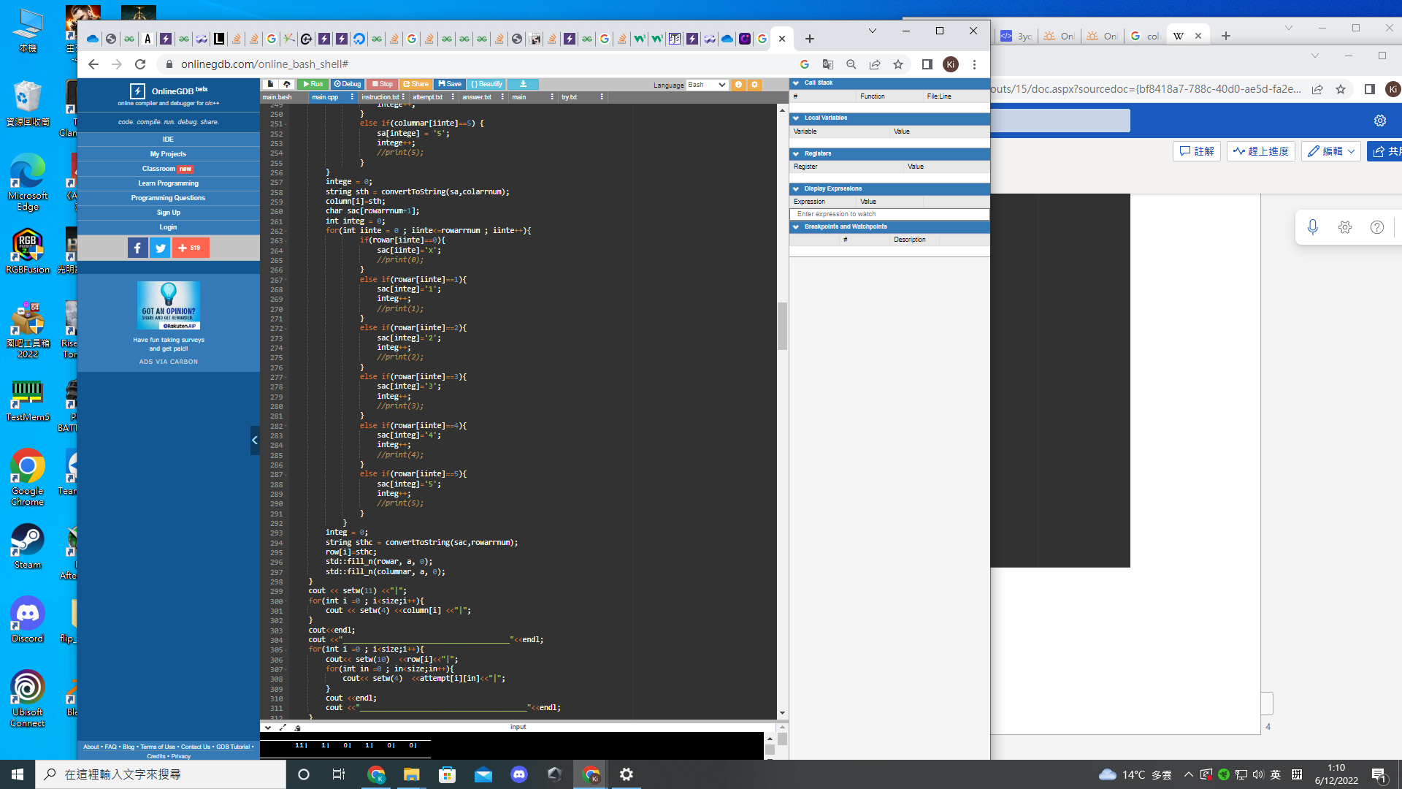

Row collum () will show the rows and collums requiremments as well as the current attempt

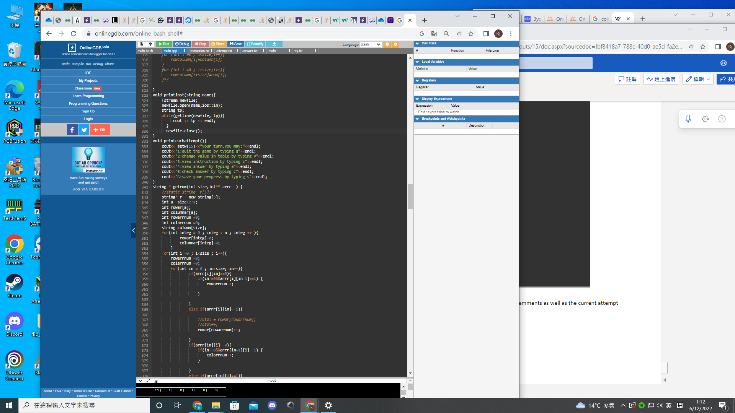

Printinst() will print the instruction for nonogram game from instruction.txt

Printeachattempt () will print what players can do

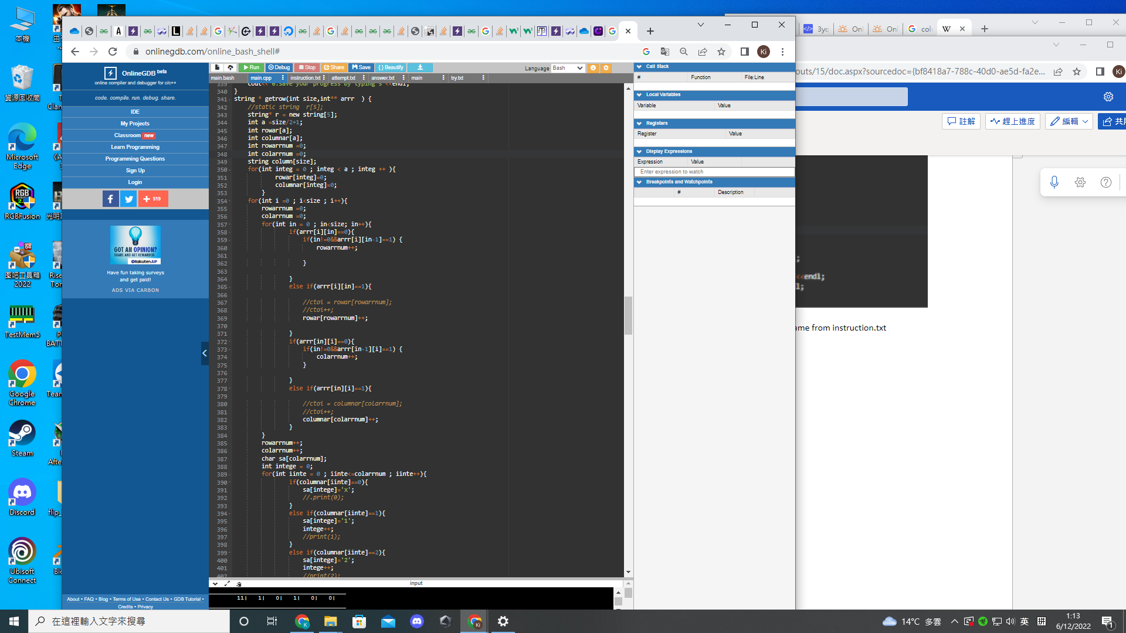

Get row()/get column() will generate the sets of number for each rows and column according to the 2d array, then the array the consist of the generated rows or collumns can be compareby the function check() to examine whether the players is correct

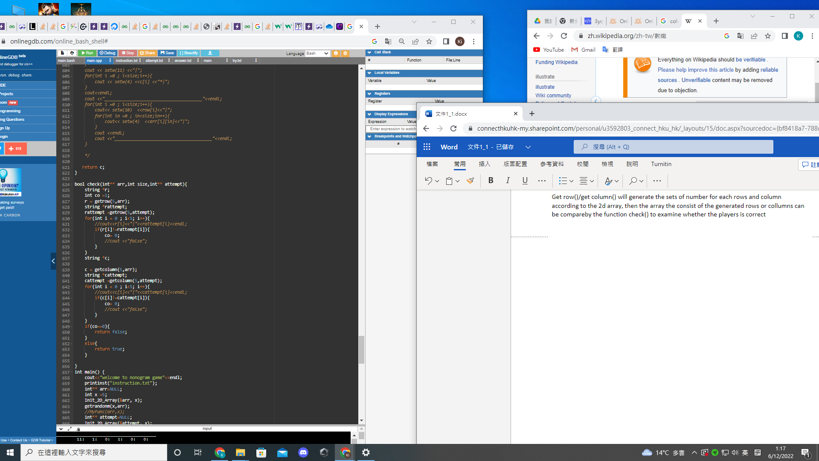

Main()

Cout will print the title of the game

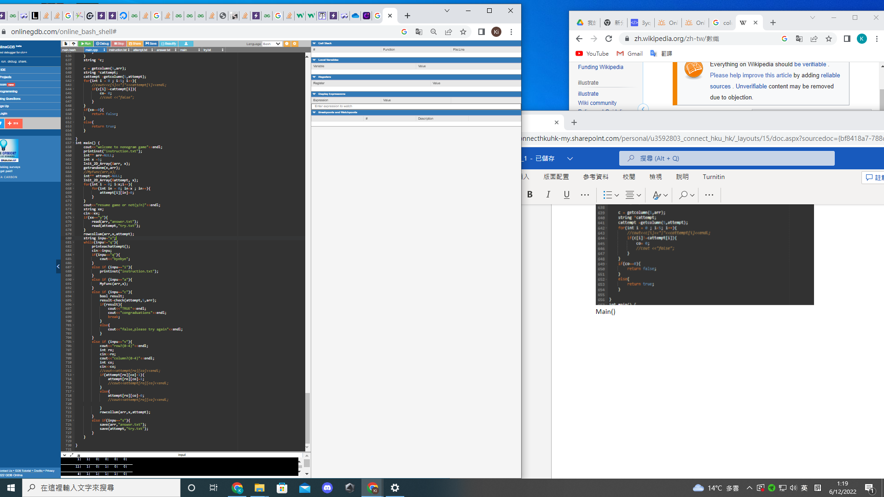

3.Work flow of the game:

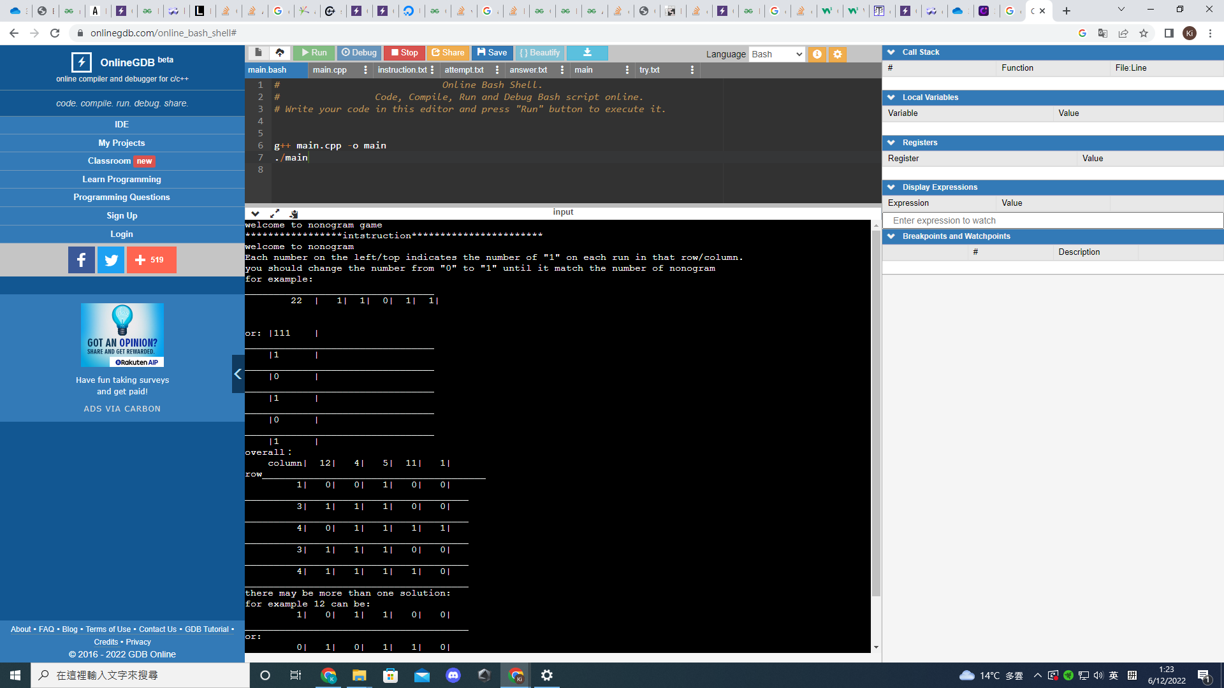

./main will show the title and the game instruction

Then we may choose to resume the game or not

If press (n) for new game, it will generate a new sets of rule, and all spaces to 0 represent not been filled.

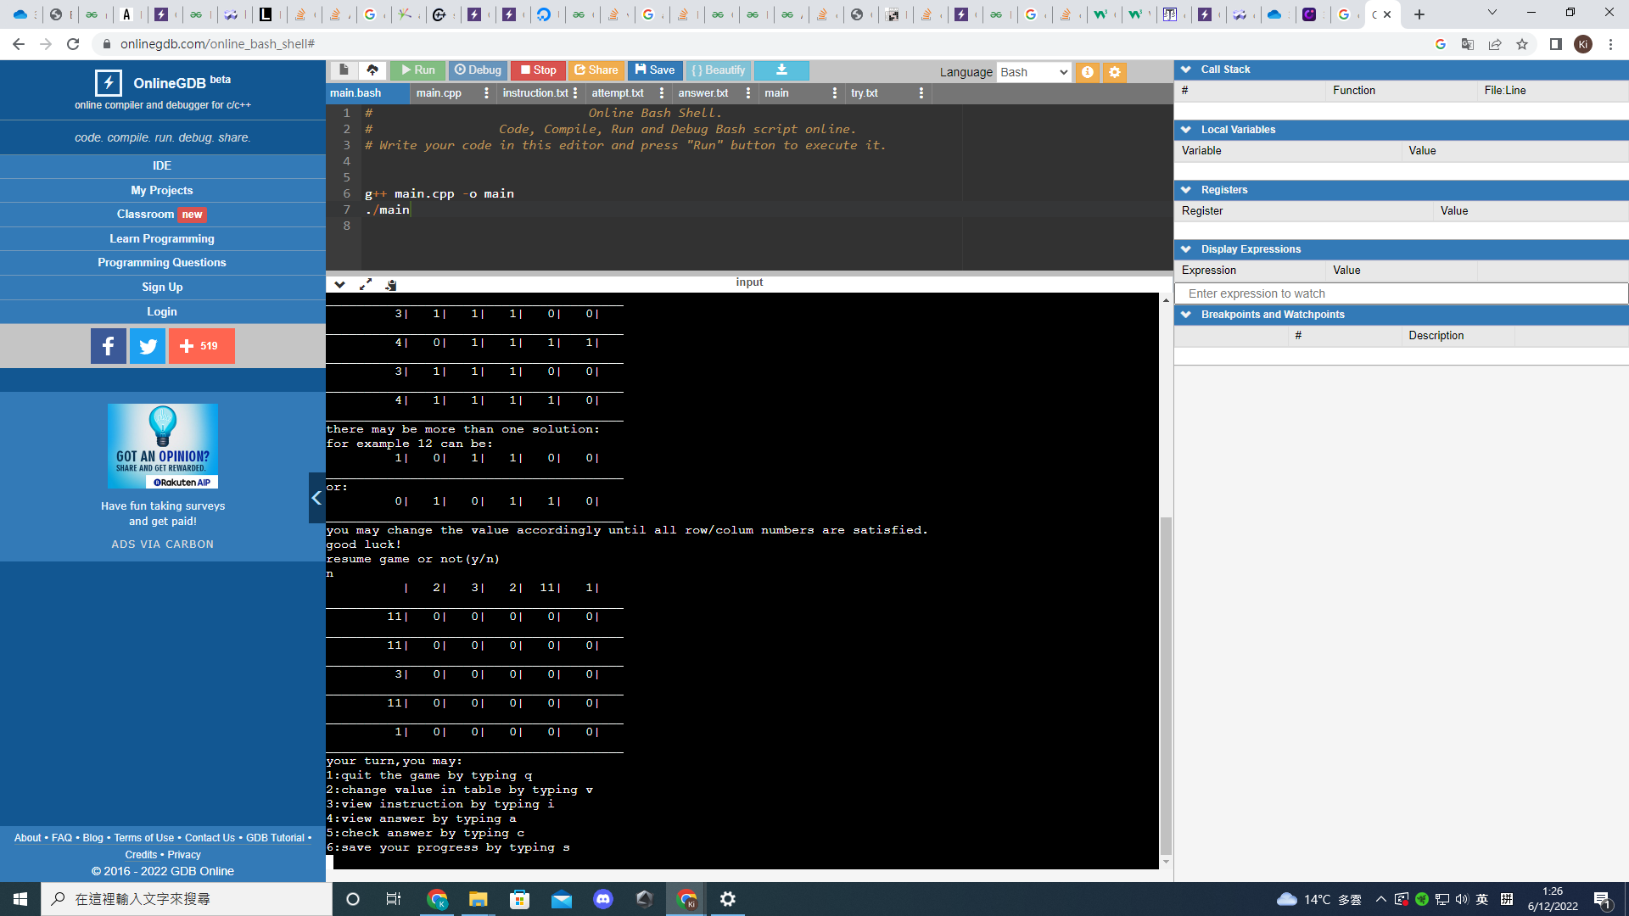

We may press “i” if we would like to view the instructions again

If we press v to swith the spaces,the program will ask which row and which column

e.g we answer 0 row and 4 column

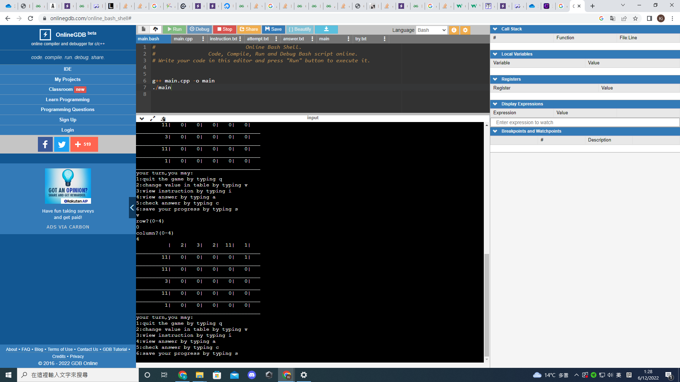

Arr[0][4]will swith accordingly between “1” and “0”.

We mignt press s and q to save and quit our game progress.

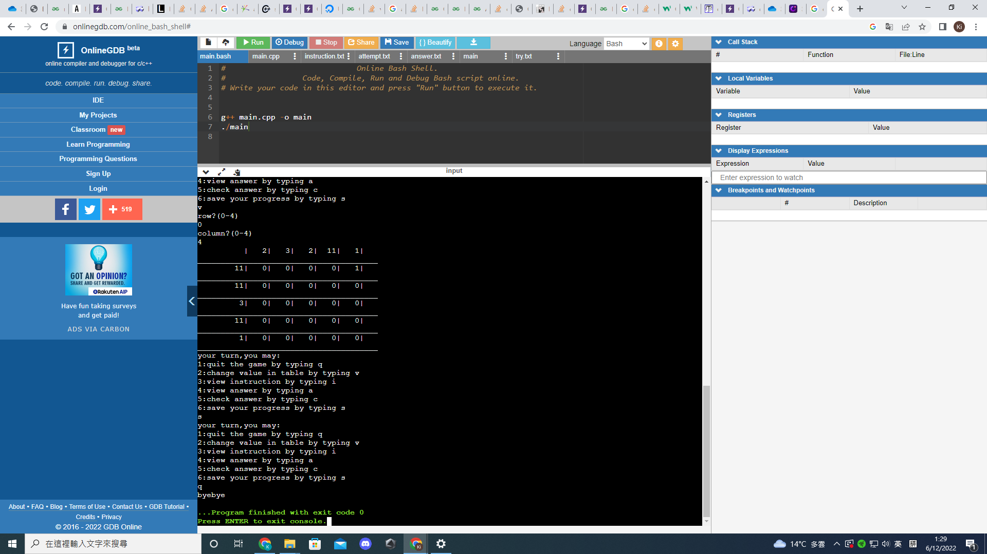

Then the answer.txt will save the correct answers and try.txt will save the input by users

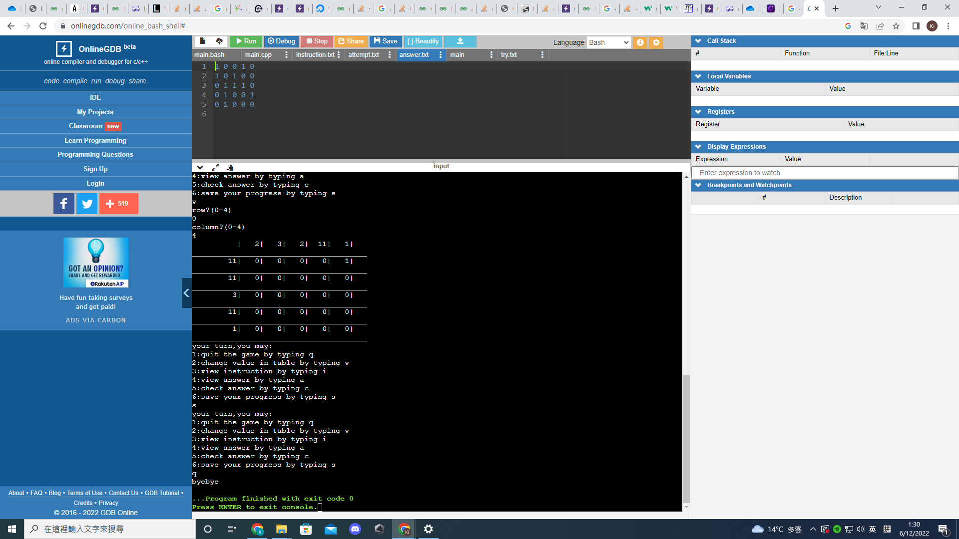

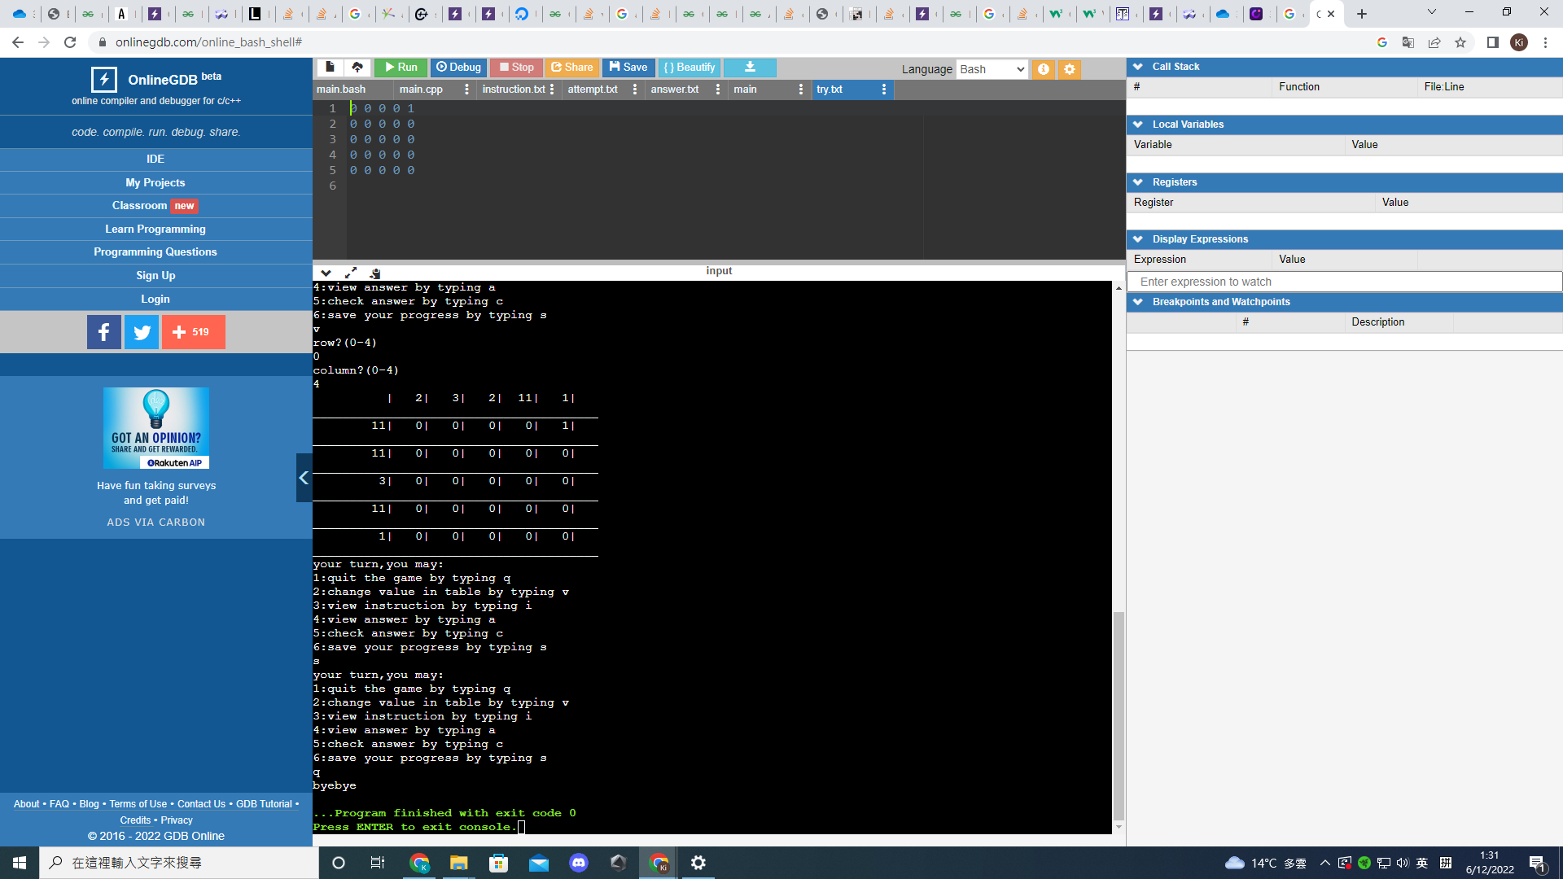

If we run the cpp again and press (y) to resume the last saved session

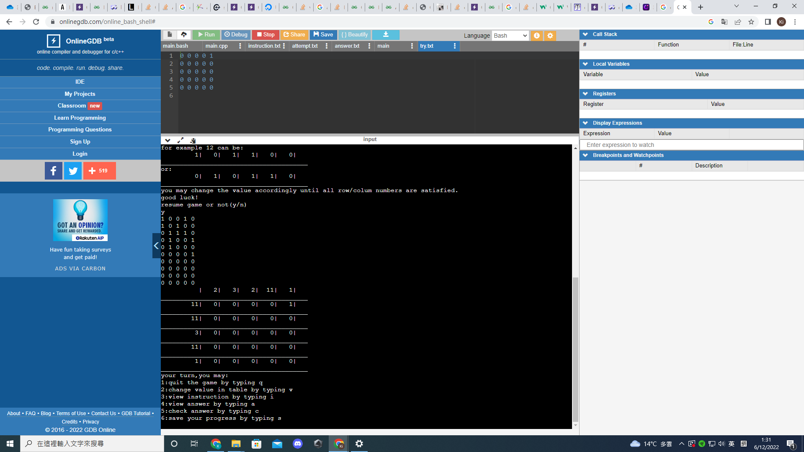

We will see the last-modified game will correct spaces and sets of number.

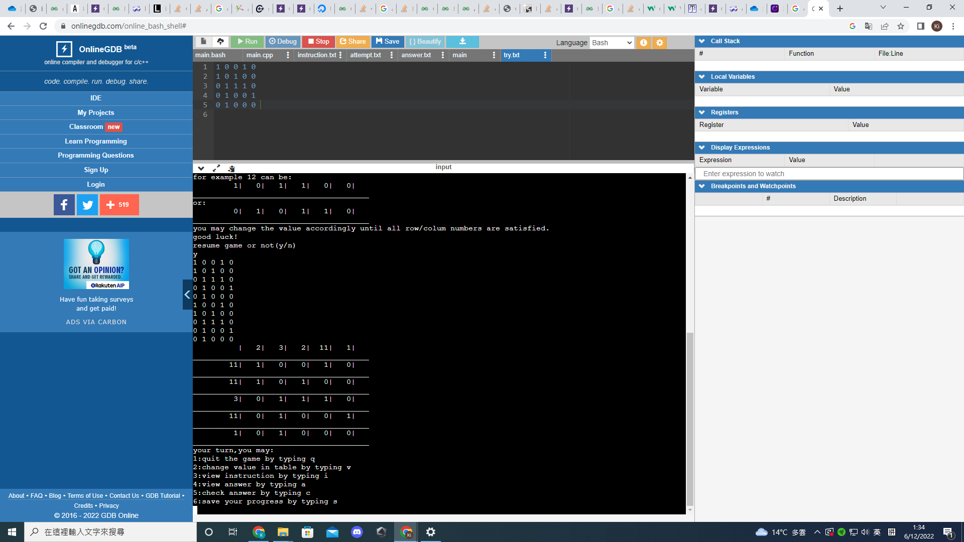

Assume now the input exatly match the sets of requirements, if we press c to check the answer

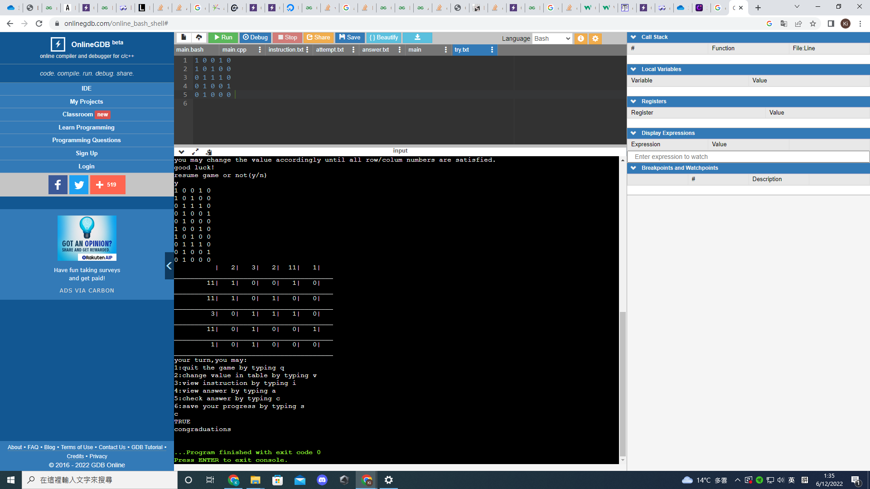

It will show true and congraduation

Now we resume the game to recover the correct answer input by users and change the answers by input v, row:0 ,column:0

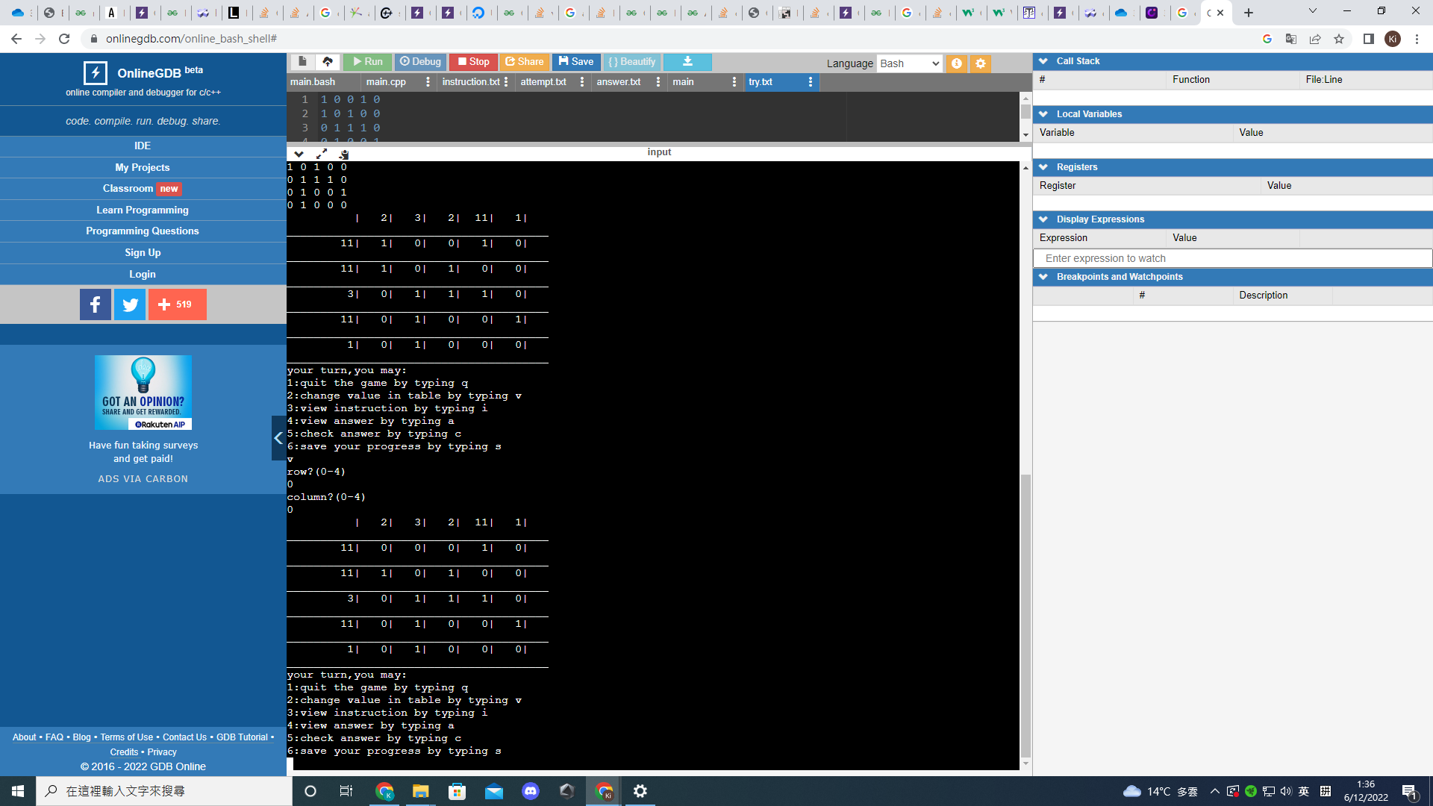

If we then check the answer,it will shows false,try again

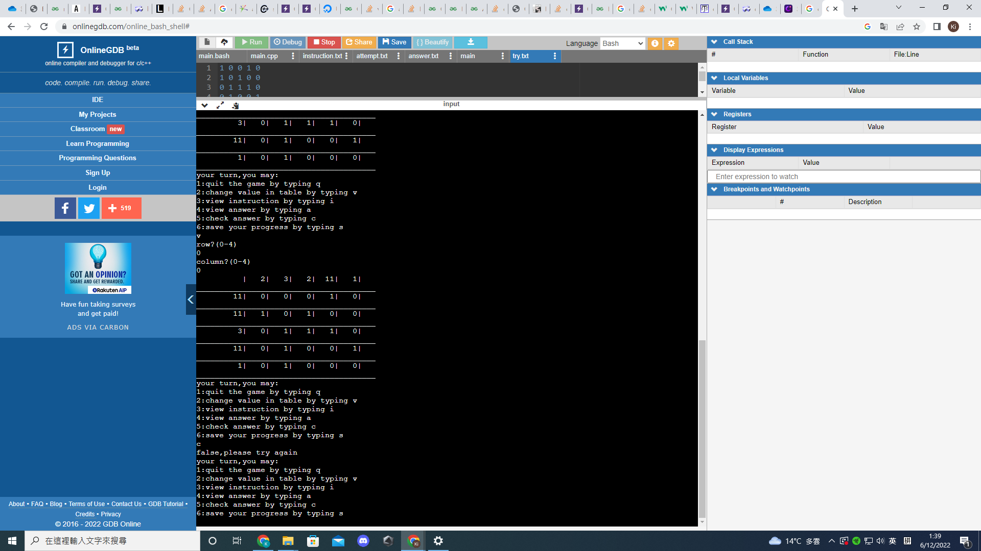

Identification of the team members:

Yuen Ki UID 3035928031

coding requirements:

1. Generation of random game sets or events

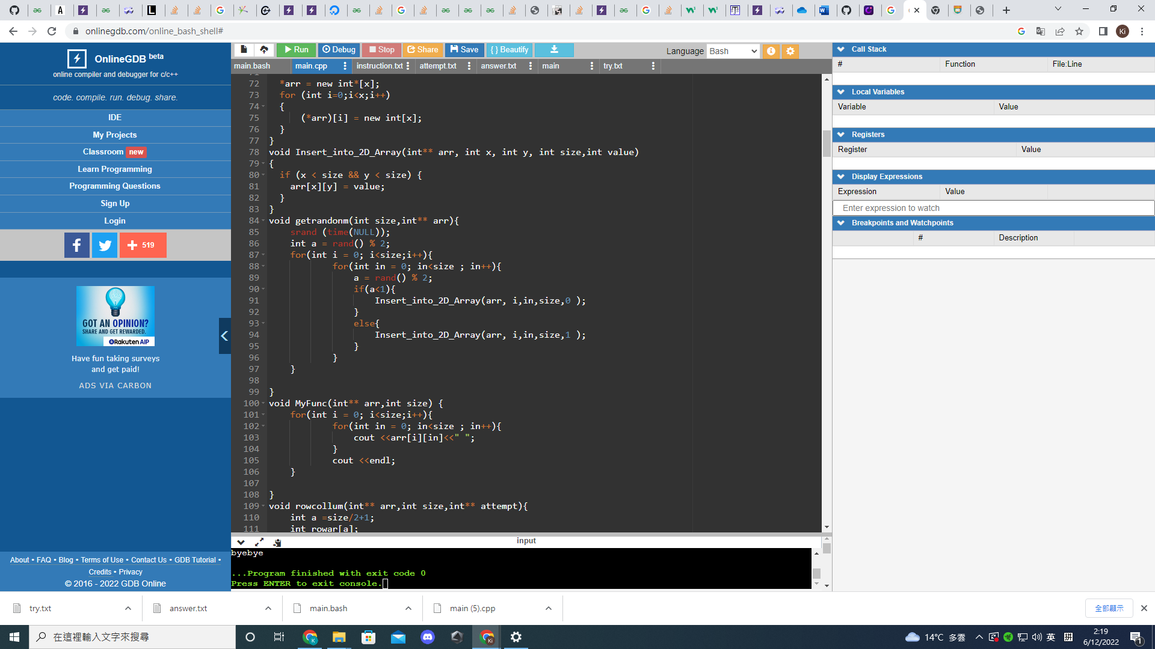

Get random() will generate random number(either 1, or 0)

By rand()%2

2. Data structures for storing game status

Two txt file (answer.txt)(try.txt) for storing concurrent game status(the 2D-array)

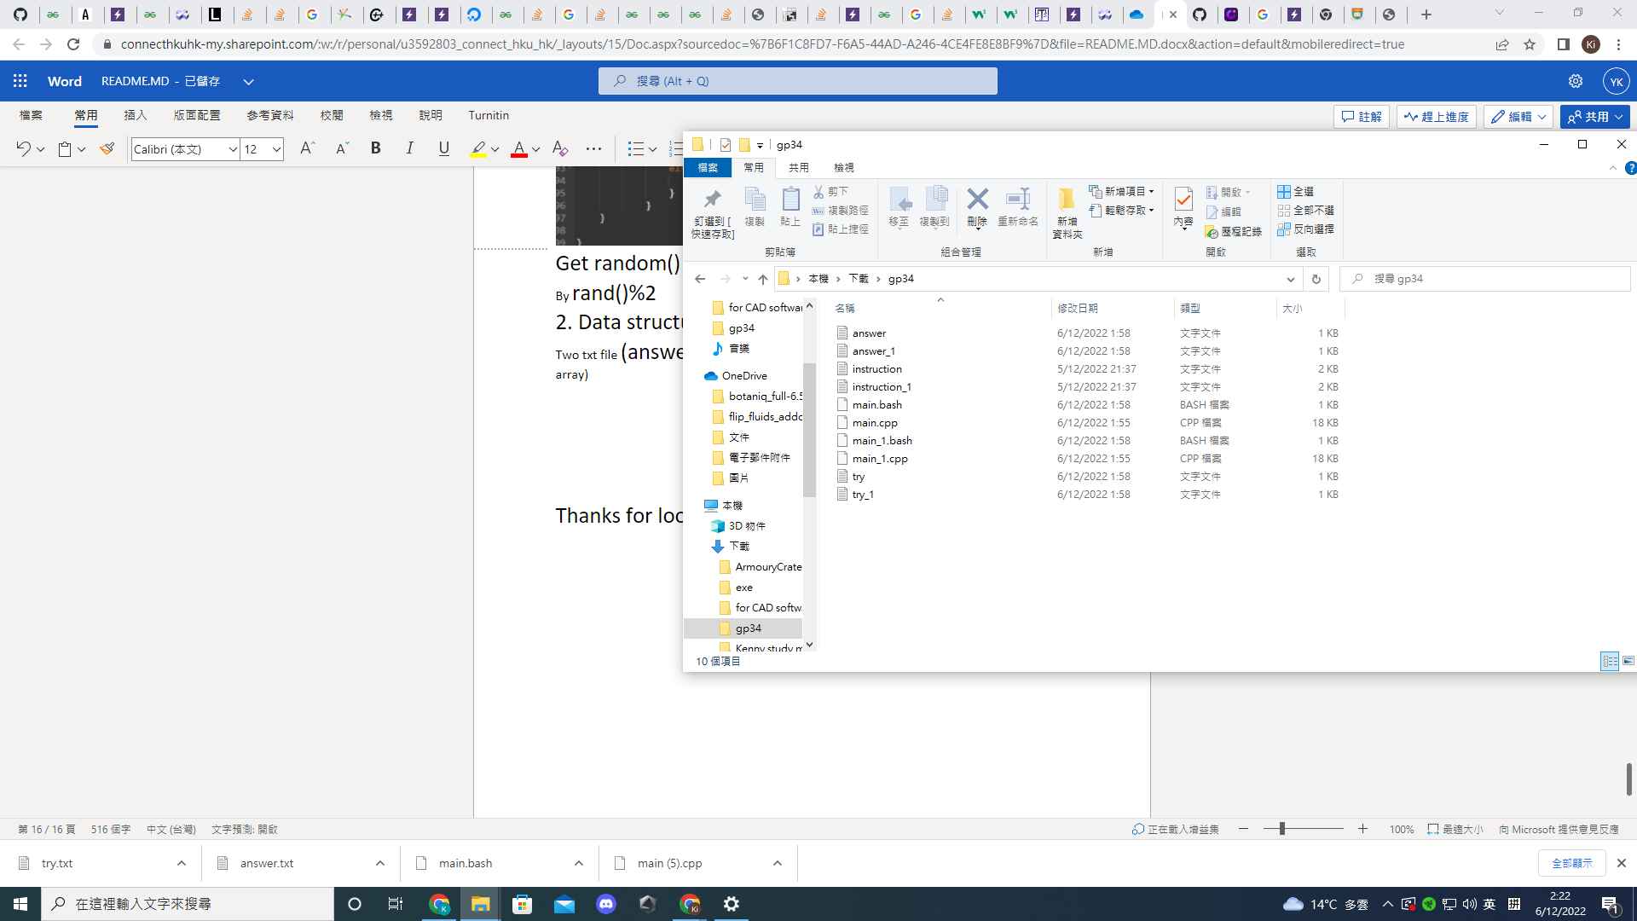

3. Dynamic memory management

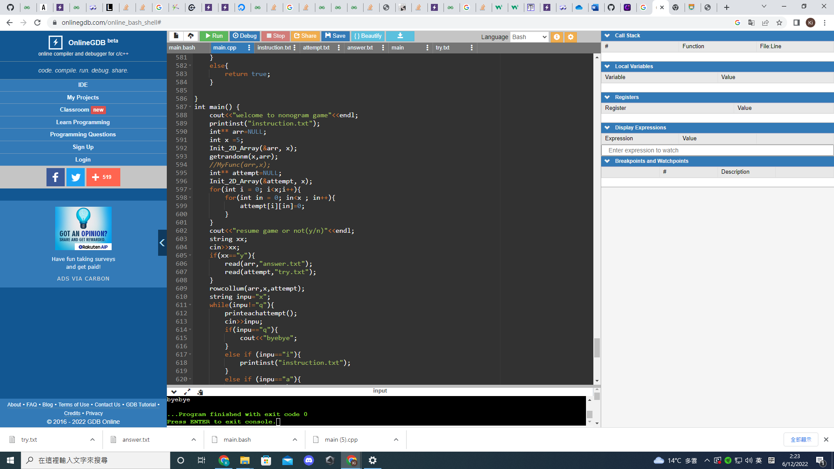

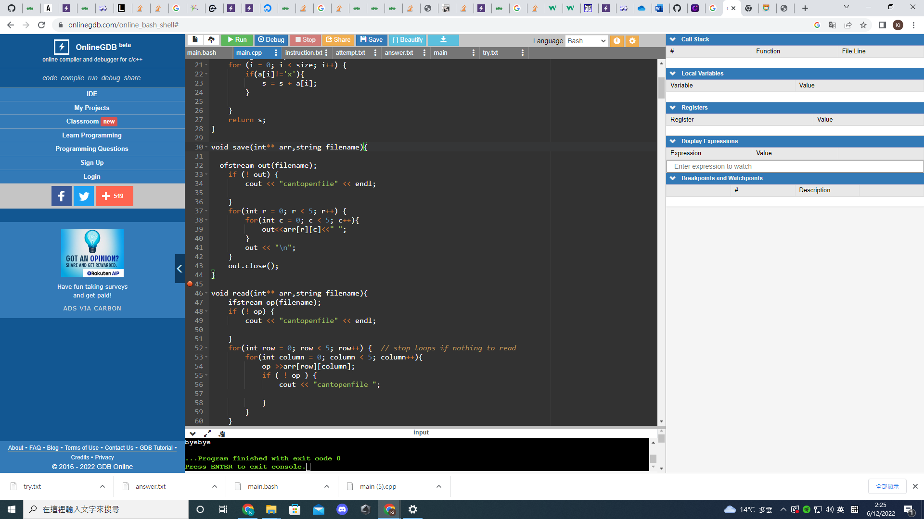

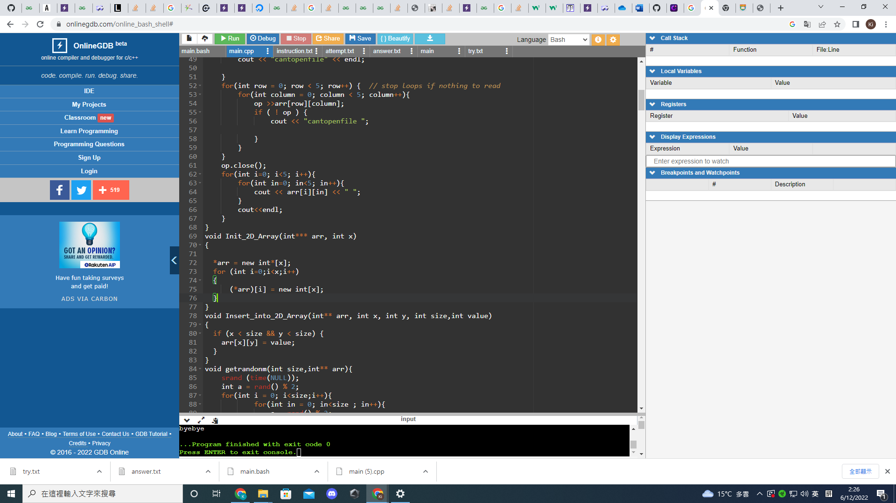

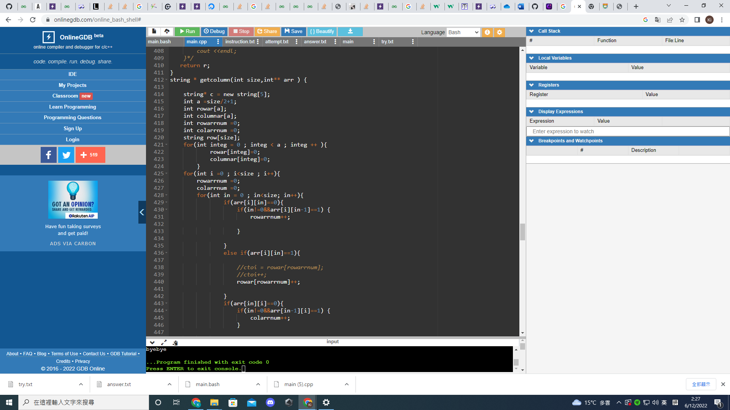

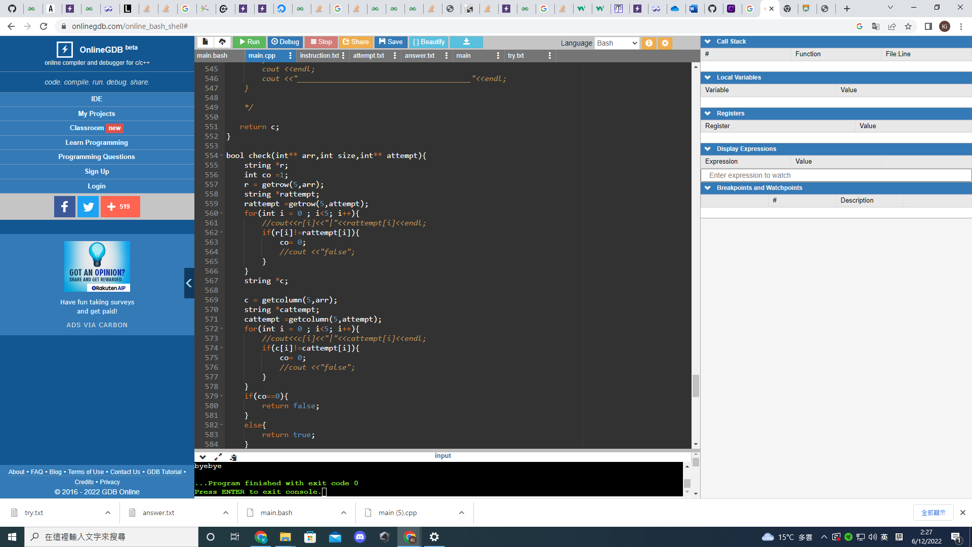

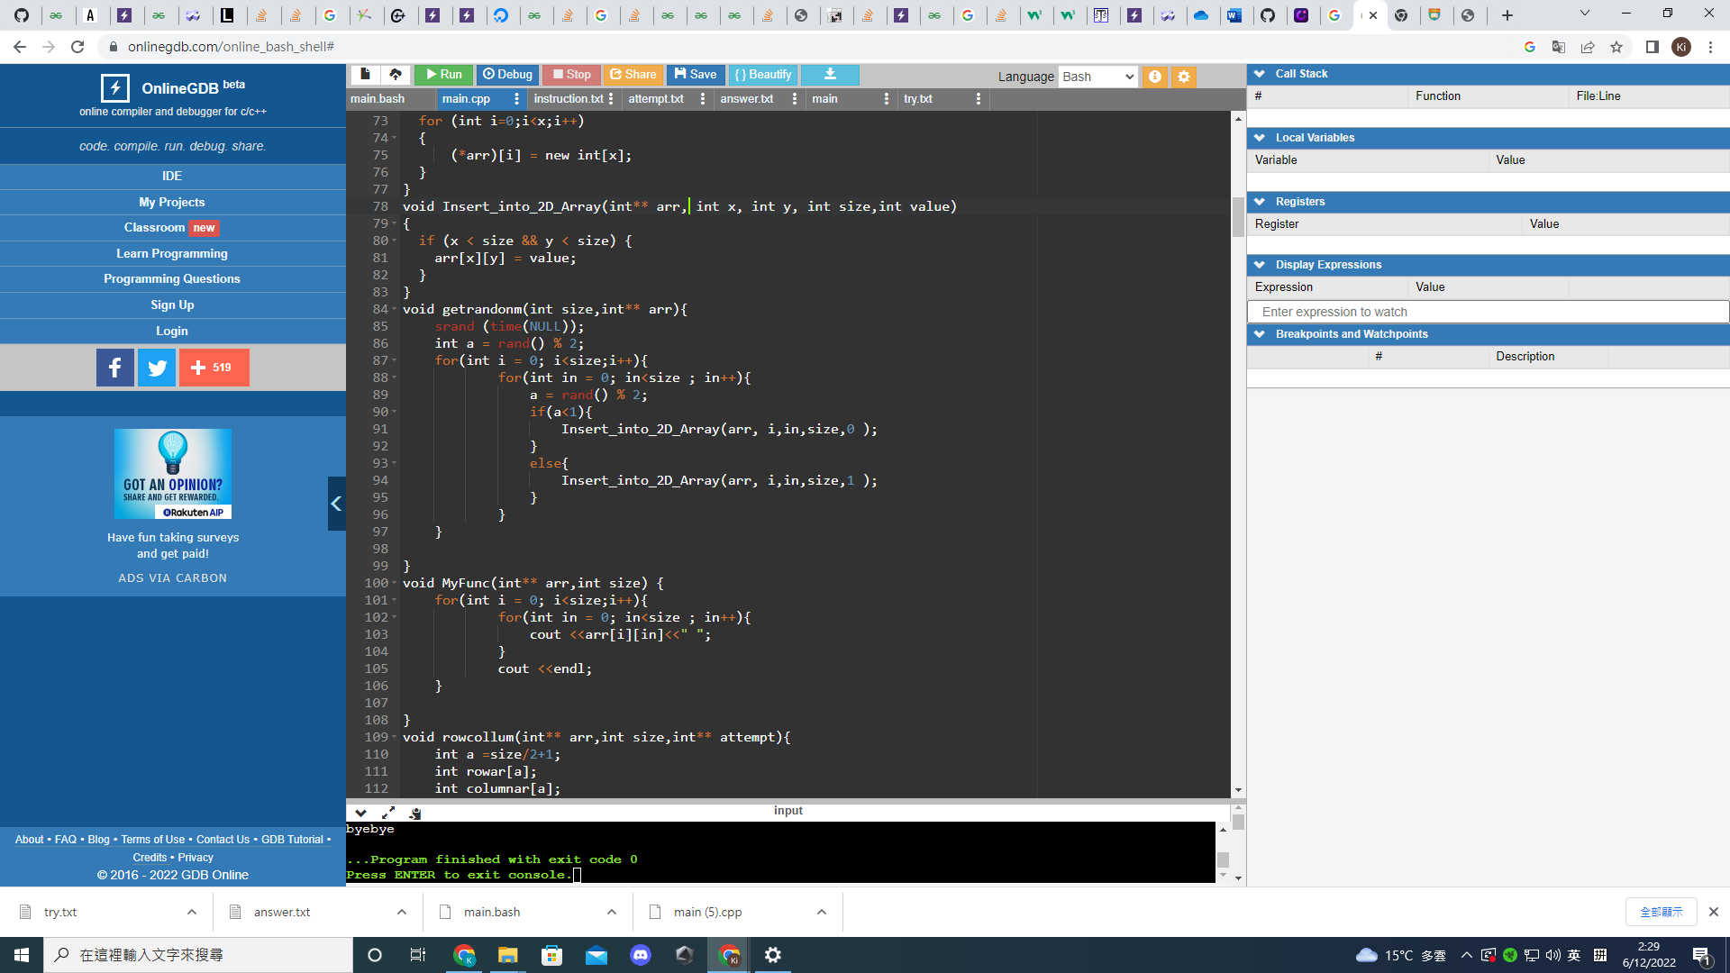

File input/output:

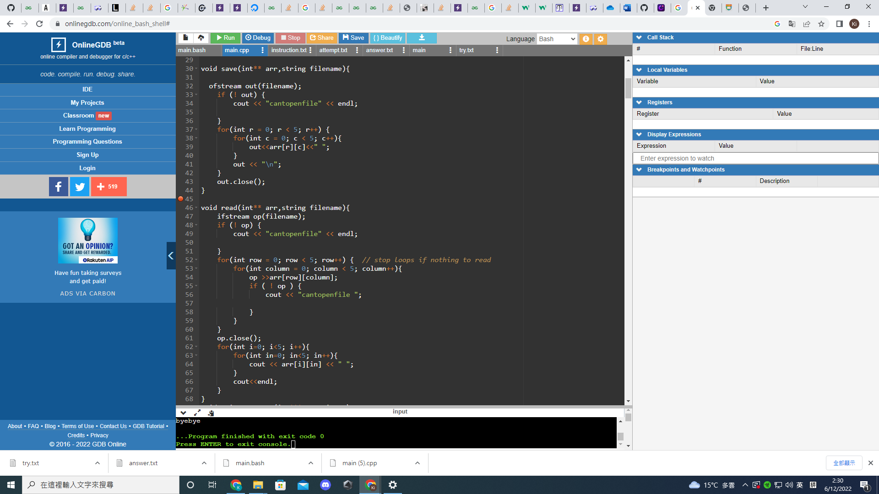

Proper indentation and naming styles:

**Init_2D_Array(&arr, x);** represent creating the array

**getrandonm(x,arr);** represent getting random correct answers

r**ead(arr,"answer.txt");** arr refer to the model answers 2d array

**read(attempt,"try.txt")**; attemt refer to the inputs anwers by players

**printinst("instruction.txt");** it will print the intructions

In-code documentation:

